**STAT 461**

**Xiangyu Ren**

***Experimental Design Project***

***Introduction***

In this project, I will conduct an experiment to find the factors that have influences on the usage of battery of the device while playing videos. People use their phones or tablets every day. They use the devices as: an excellent media to communicate, a great platform to watch videos, or a nice place to share their lives. Since we spend so much time on our devices every day, I am curious that what are the factors that affect the usage the batteries of devices, especially when watching videos.

***Statistical Model***

$$Y_{ijt}=μ+α_{i}+β_{ij}+ϵ_{ijt}, ϵ_{ijt}\overset{iid}{∼}N(0,σ^{2})$$

$$i=played,paused j=highResolution,lowResolution t=1,2,3,4,5$$

***Treatments, Responses, and Description***

In the experiment, there will be 2 treatments as it showed in the formula of the stat-model. The first treatment is whether the video is played or not, there will be 2 situations: played or paused. The second treatment is whether the video is set to high resolution or not: in this case, I choose 1080p as high resolution and 480p as low resolution. There are 5 responses for each treatment, thus totally there will be 20 responses. The response variable for the experiment is the time it takes for the device dropping from 100% battery to empty battery (longer is better).

I will test on the same device, same application, and played same video. Testing on the same device for such a long time – emptying battery for 20 times, might take damages to the battery, but I would ignore that residual to the result. I will try to randomize the experiment as much as possible. I built a list in the R code with different treatments and used the code to randomize the list of 20 responses such that I can get a sequence of testing. For the application of playing video, I enumerated all the apps, and used a random selector to get the index of app.

After all things are ready, I conducted the experiment on my old iPhone. I would leave the phone with screen-on the whole time until it is out of battery. For each testing, I would either choose to play the video with auto-play after ends (so it won’t stop playing) or pause the video, or either with high resolution or low resolution. Once the screen turns off, I record the time in unit of minutes.

***Confounders***

There are some possible confounders in the experiment. Since I only tested on the same device, same application, and playing same video, the result might change once I change one of those factors. Such as an iPad might stand longer than an iPhone, or playing videos on YouTube might have different usage of battery from playing videos on Netflix, or play a black-and-white movie might need less battery than a colorful movie, etc.

***Analysis***

In total, I collected 20 sets of data: 5 for playing high resolution videos, 5 for playing low resolution videos, 5 for pausing high resolution videos, and 5 for pause low resolution videos.

*Here is the ANOVA table:*

## Analysis of Variance Table  
##   
## Response: time  
## Df Sum Sq Mean Sq F value Pr(>F)   
## situation 1 3110.02 3110.02 93.3770 4.415e-08 ***  
## resolution 1 495.01 495.01 14.8625 0.0014 **   
## situation:resolution 1 117.32 117.32 3.5225 0.0789 .   
## Residuals 16 532.90 33.31   
## ---  
## Signif. codes: 0 '***' 0.001 '**' 0.01 '*' 0.05 '.' 0.1 ' ' 1

According to the anova table, all the p-values except the interaction between situation and resolution are less than 0.05, thus it means that all other variables, situation – playing or pausing, resolution – high or low are significant to the standing time of the device battery.

*Here, I conduct the residual graph and normal QQ-plot:*

After reading the graph of Normal QQ-plot and the residual graph. The normal QQ-plot seems like a straight line, so I conclude that it is perfectly normal. Also, the assumption of constant error variance among treatments is justified since the residuals are in a square shape. Therefore, we do not need any transformation.

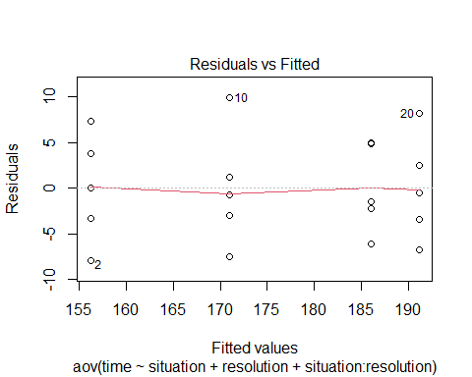 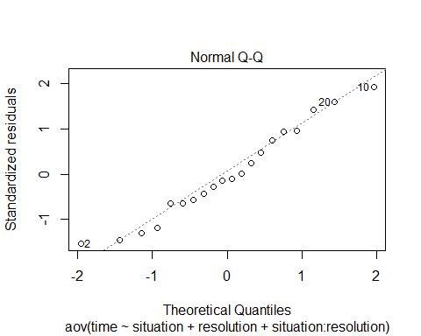 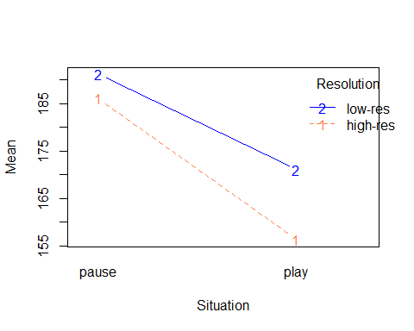

Above is the interaction plot of play or pause video with high or low resolutions aside. It is obvious that these two lines have no interaction which means they have a great chance of significant difference.

*Give a hypothesis test with following $α=0.05$*

$$H_{0}:(αβ)_{ij}=0 for all i,j vs. H_{a}:at least one treatment is different$$

## situation resolution lsmean SE df lower.CL upper.CL .group  
## play high-res 156 2.58 16 151 162 1   
## play low-res 171 2.58 16 166 176 2   
## pause high-res 186 2.58 16 181 191 3   
## pause low-res 191 2.58 16 186 197 3   
##   
## Confidence level used: 0.95   
## P value adjustment: tukey method for comparing a family of 4 estimates   
## significance level used: alpha = 0.05

## Analysis of Variance Table  
##   
## Response: time  
## Df Sum Sq Mean Sq F value Pr(>F)   
## situation 1 3110.02 3110.02 93.3770 4.415e-08 ***  
## resolution 1 495.01 495.01 14.8625 0.0014 **   
## situation:resolution 1 117.32 117.32 3.5225 0.0789 .   
## Residuals 16 532.90 33.31   
## ---  
## Signif. codes: 0 '***' 0.001 '**' 0.01 '*' 0.05 '.' 0.1 ' ' 1

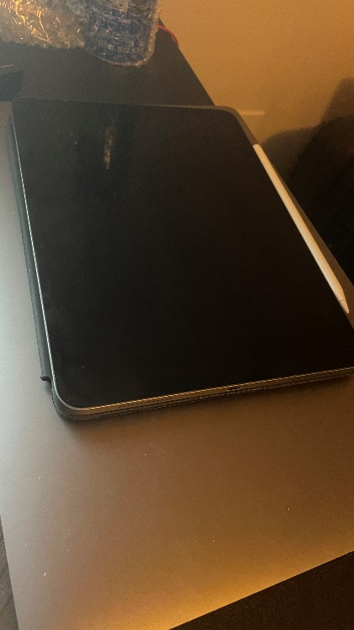Above is the contrast table and the anova table, we can see that obviously that, play high resolution videos is significantly different with play low resolution videos or pausing high or low resolution videos. According to the anova table, the p-value for variables situation and resolution are both less than $α$, therefore we can say that we reject $H_{0}$, and we can conclude that there are at least one treatment that is significant different.